Assignment No .1 MM 10
Q1. A digital computer has a common bus system for 16 registers of 32 bits each. The bus is constructed with multiplexers.
- How many selection inputs are there in each multiplexer?
Ans. Since 2⁵=32, there are 5 selection inputs in each given Multiplexer
- What size of multiplexers are needed?
Ans. Since each Register is 32 bit sized, 32 bit sized Multiplexers are needed
- How many multiplexers are there in the bus?
Ans. There are 16 Registers, so 16 Multiplexers are there in the bus
Q2. The following transfer statements specifies a memory. Explain the memory operation in each case.
- R₂ <-M[AR]
Ans. This is the transfer of information from Memory word M selected by address in AR into Register R₂
- M[AR] R₃
Ans. This is the transfer of information from R₃ Register into Memory word M selected by address in AR.
- R₅ M[R₅]
Ans. This is the transfer of information from Memory word M selected by address in R₅ Register into Register R₅.
Q3. Describe three state bus buffer . Draw the diagram of three state buffer .
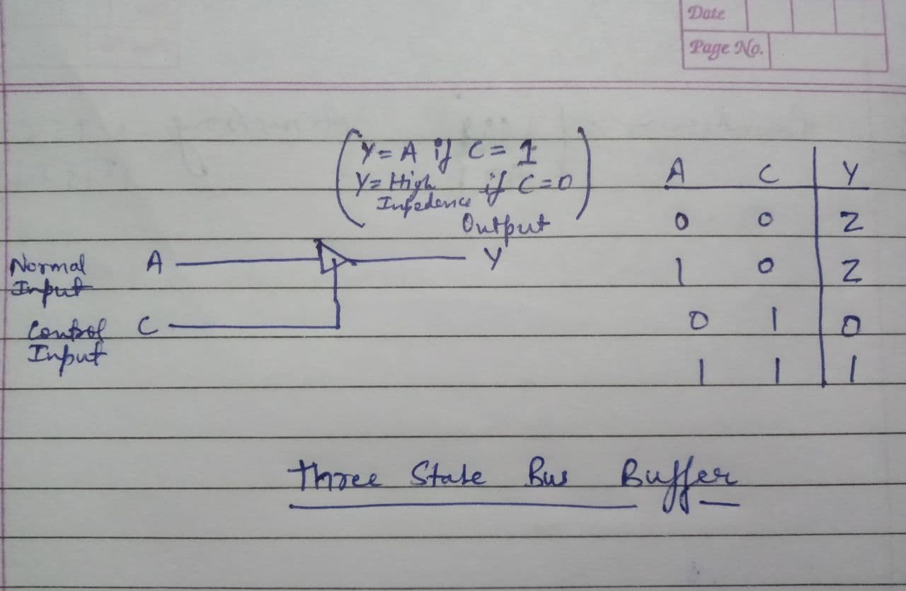
Ans. A three state bus buffer has three states 0, 1 & High Impedance. The graphic symbol of a three-state gate is distinguished from normal buffer by having both a normal input and a control input.

